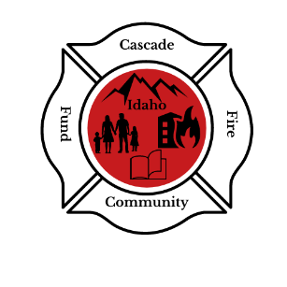
Cascade Fire Community Fund, Inc
P.O. Box 589, Cascade, Idaho, 83611
Cascadefirecommunityfund@gmail.com
Cascade Fire Community Fund
Scholarship Program
The Cascade Fire Community Fund is offering a scholarship to Graduating high school students or a community member interested in beginning or advancing their career in being a First responder (Police, Emergency Medical, Rescue or Fire). The scholarship will be awarded up to $3,000.00.
Who may apply?
This scholarship is open to any current graduating senior from Cascade High school or McCall Donnelly High school.
This scholarship is now being opened to community members wishing to begin or advance their Career being a First Responder.
Requirements
High school students must have a grade point average of 2.8 or better on a 4.0 scale.
Applicants must start or continue their education in the fire service, Emergency medical service, or law enforcement.
- A brief resume including your community involvement and accomplishments.
- Awards or recognitions during your high school years or during your current career.
- A letter explaining your educational and career plans. Please include:
  - What college or university do you plan to attend?
  - What are your career goals?
This scholarship is to be paid after successful completion of the first semester or official grade period of college or vocational school, selected by the recipient.
All applicants for this scholarship must include two letters of recommendation along with your application. These letters can be from a teacher, a community member, past or present employer. Applications must be sent to Cascadefirecommunityfund@gmail.com or by mail to P.O. Box 589, Cascade, Idaho 83611 Attn: Cascade Fire Community Fund.
Deadline to Apply
The application deadline is 5:00 PM on April 26th, 2025, and must be received by your Guidance counselor or by Cascade Fire District.

